503IT Communication and Collaboration
Week 3 Student Task Pack: Prototype Development, Appendices, Presentation and Individual Portfolio
Project: Cyber-Smart Gaming for Education
Purpose of this Week 3 Task Pack
You now have only three teaching weeks left to complete the group game project, prepare the 15-minute group presentation, and write your individual portfolio/report.

This week is not for restarting your idea. This week is for building, testing, recording evidence, organising appendices, and preparing the presentation. Every group must use GitHub as the project evidence space, and every student must keep a clear individual contribution record.

1. What Week 3 Is About
Session | Main focus | What this means for your project
Week 3 Session 1 | Advanced development work | Run an independent team meeting, review blockers, continue prototype development, and capture evidence.
Week 3 Session 2 | Independent team meetings and appendices | Organise evidence into appendices and learn how to link evidence properly in the individual portfolio.
Week 3 Sessions 3 & 4 | Presentation skills and assessment recap | Practise short presentation sections, review assessment requirements, check missing evidence, and plan remaining tasks.

2. What You Should Already Have Completed Before Week 3
Previous task | Expected evidence in GitHub | Complete?
Group formation and roles | Day-1-Group-Formation folder with group-members, role-allocation, meeting notes and reflection | Yes
Game concept and storyboard | Day-2-Concept-Development folder with canvas, storyboard, final topic and target audience | Yes
UX and accessibility improvement | Week-2-Session-1-UX-Accessibility folder with UX review, improved canvas/storyboard and peer feedback | Yes
Tool selection | Week-2-Session-2-Tool-Selection folder with tool comparison, final tool choice and development plan | Yes
Prototype Version 1 started | Week-2-Prototype-Start folder with build plan, screenshots/link/file, testing plan and meeting notes | Yes

3. Main Outputs Required by the End of Week 3
Output | What must be completed | Where it must be saved/uploaded
Prototype Version 2 | Improve the first prototype by adding more interaction, clearer feedback, and at least one more challenge or screen. | GitHub: Week-3-Development-Testing/
Team meeting minutes | Run a proper meeting with chair and minute-taker. Record agenda, decisions and actions. | GitHub: Week-3-Development-Testing/meeting-06-minutes.md
Testing evidence | Test the prototype internally and through peer testing. Record issues and improvements. | GitHub: Week-3-Development-Testing/testing-results.md and Peer-Feedback/
Appendix plan | Organise your portfolio evidence into appendix numbers and categories. | GitHub: Week-3-Appendix-Planning/appendix-evidence-map.md
Presentation draft plan | Create a first presentation structure with speaker roles and timing. | GitHub: Week-3-Presentation-Planning/presentation-draft-plan.md
Individual portfolio plan | Each student starts their own individual report structure and evidence links. | GitHub: Individual-Contribution-Logs/ and Week-3-Portfolio-Planning/

4. GitHub Folder Structure for Week 3
Create These New Folders in Your Group Repository
Week-3-Development-Testing/
Week-3-Appendix-Planning/
Week-3-Presentation-Planning/
Week-3-Portfolio-Planning/

You should keep your previous folders. Do not delete Day 1, Day 2, Week 2, Prototype, Peer Feedback, AI Use Evidence, or Individual Contribution Logs.

Folder | Files to create or upload
Week-3-Development-Testing | prototype-v2-plan.md, prototype-v2-evidence, testing-results.md, meeting-06-minutes.md, development-progress-reflection.md
Week-3-Appendix-Planning | appendix-evidence-map.md, appendix-numbering-plan.md
Week-3-Presentation-Planning | presentation-draft-plan.md, speaking-roles.md, presentation-practice-feedback.md
Week-3-Portfolio-Planning | individual-report-structure.md, portfolio-evidence-linking-plan.md
AI-Use-Evidence | Update ai-use-log.md for any AI support used this week
Individual-Contribution-Logs | Each student updates their own contribution log

5. Task 1 - Run an Independent Team Meeting
Why this task matters
Week 3 requires independent teamwork. Your group must demonstrate that you can organise a professional meeting, assign responsibilities, record decisions, and plan development tasks. The meeting minutes will become portfolio evidence and can be placed in the appendix.

Step | What your group must do
1 VIVEK was selected as the chairperson to manage the meeting, keep the discussion focused, and ensure that every team member participated. | Choose a chair. The chair keeps the meeting focused and makes sure everyone speaks.
2 HADSHEN was selected as the minute-taker/scribe and recorded all discussions, decisions, and action points using the meeting minutes template. | Choose a minute-taker/scribe. This student records the meeting using the meeting minutes template.
3 The group reviewed the current progress of the game project by opening the repository on GitHub and checking uploaded files, commits, screenshots, and development evidence. | Review current project progress. Open GitHub and check what is already uploaded.
4 Hangma identified blockers such as unfinished prototype features, missing appendix evidence, testing issues, and limited time remaining before the submission deadline. | Identify blockers. Discuss what is not working, what is missing, and what needs help.
5 Development responsibilities were assigned to all members: VIVEK worked on prototype development, Swastika organised the appendices and documentation, and HANGMA prepared the group presentation. | Assign today’s development tasks. Every student must have a visible responsibility.
6 The group recorded all decisions and action items in the meeting minutes to ensure that responsibilities, deadlines, and project tasks were clearly documented for future reference and portfolio evidence. | Record decisions and action items. Do not rely on memory.

Meeting Minutes

Section | What to write
Meeting details | Date: 21/05/2026  Time: 9:00 – 17:00  Location: Class Room No.208  Chair: VIVEK  Minute-taker: HADSHEN  Attendees: HANGMA  Deadline: 21/05/2026 at 17:00
Agenda items | Prototype Development, Appendices, Presentation
Decisions made | We now have only three teaching weeks left to complete the group game project, we will prepare the 15-minute group presentation, and write our individual portfolio/report.  This week is not for restarting our idea. This week is for building, testing, recording evidence, organizing appendices, and preparing the presentation. We must use GitHub as the project evidence space, and every members must keep a clear individual contribution record.
Action items | Activity | Responsible Person
 | Prototype development | VIVEK
 | Appendices | HADSHEN
 | Presentation | HANGMA
Next steps | The team will continue working on the game prototype by completing the remaining development tasks and carrying out testing to ensure that all features function correctly. All project progress, including screenshots, testing results, and contribution records will be uploaded to GitHub as evidence of development work.  The appendices will be finalized and organized properly, while the group presentation will be prepared and rehearsed to ensure it fits within the 15-minute time limit. In addition, each member will begin completing their individual portfolio/report by documenting their contributions, reflections, and supporting evidence.

6. Task 2 - Build and Improve Prototype Version 2

Prototype Version 2 Build Plan
Prototype part | Minimum improvement required | Responsible student | Evidence to upload
Welcome/instruction | Clearer instructions or improved start flow | VIVEK | 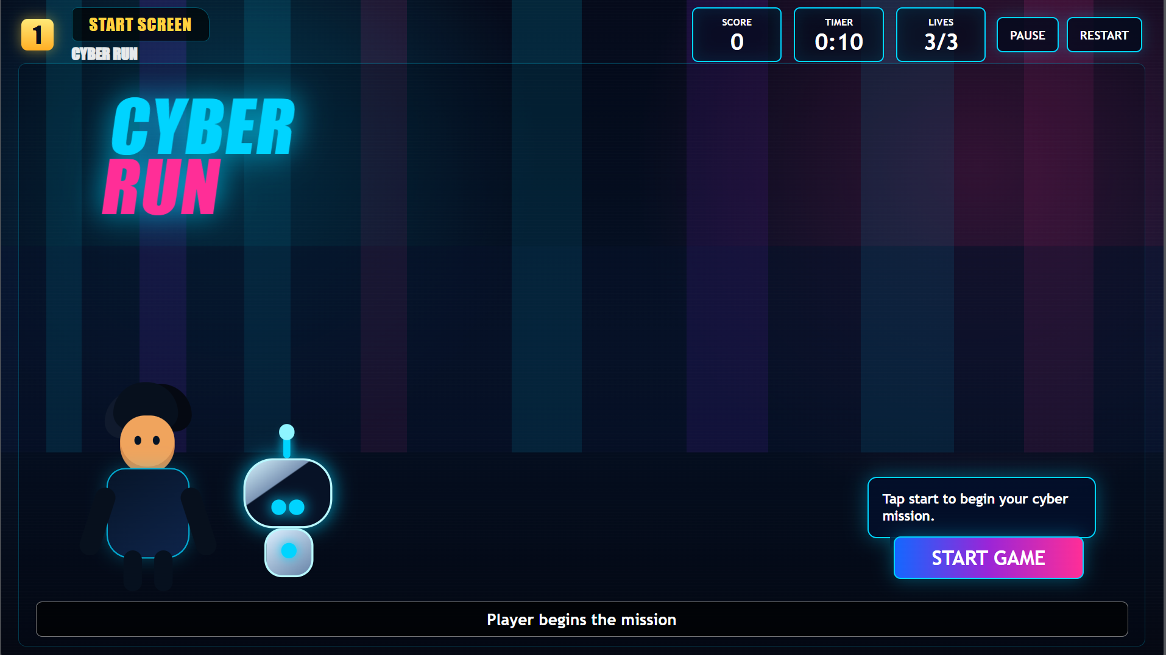
Challenge 1 | Fix any issue found in testing | All members | 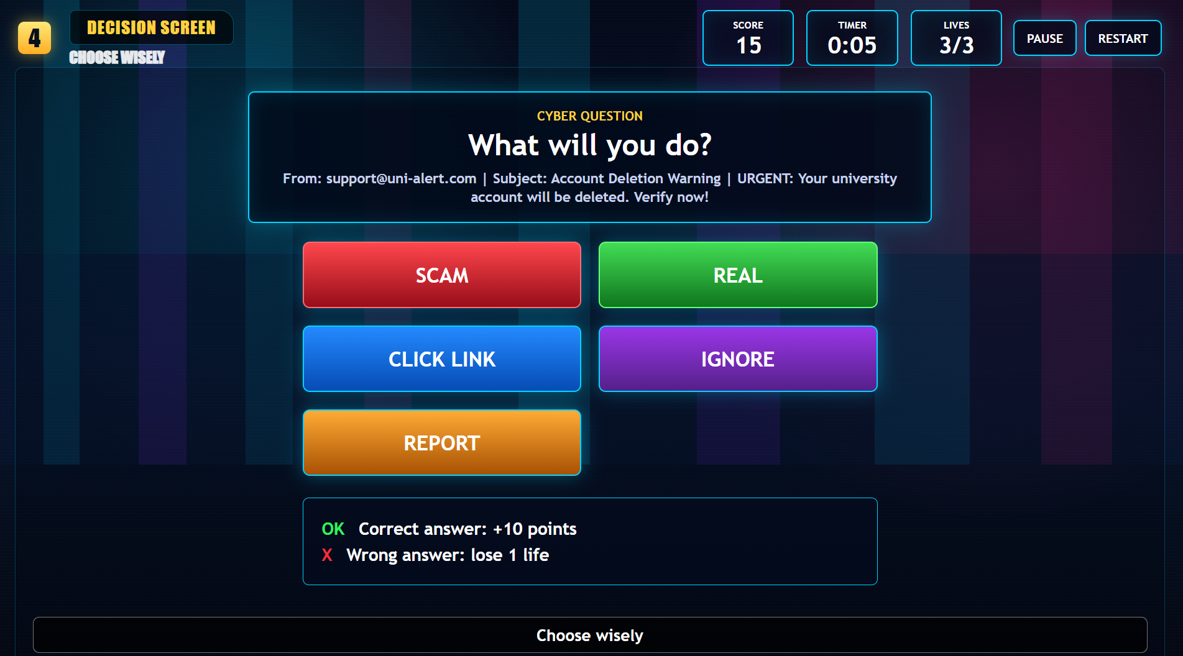
Challenge 2 or extra interaction | Add at least one new question/scenario/interaction if possible | All members | 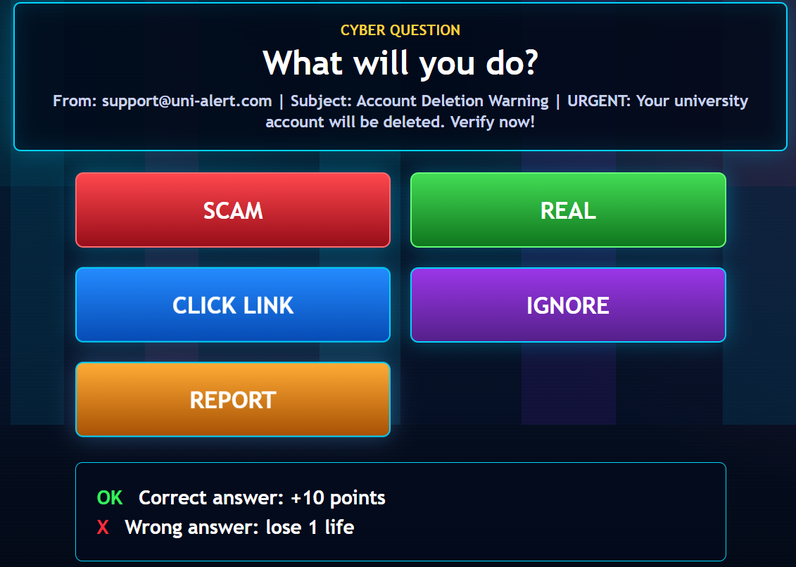
Feedback system | Feedback must explain the cyber-safety lesson, not only say correct/wrong | Hadshen | 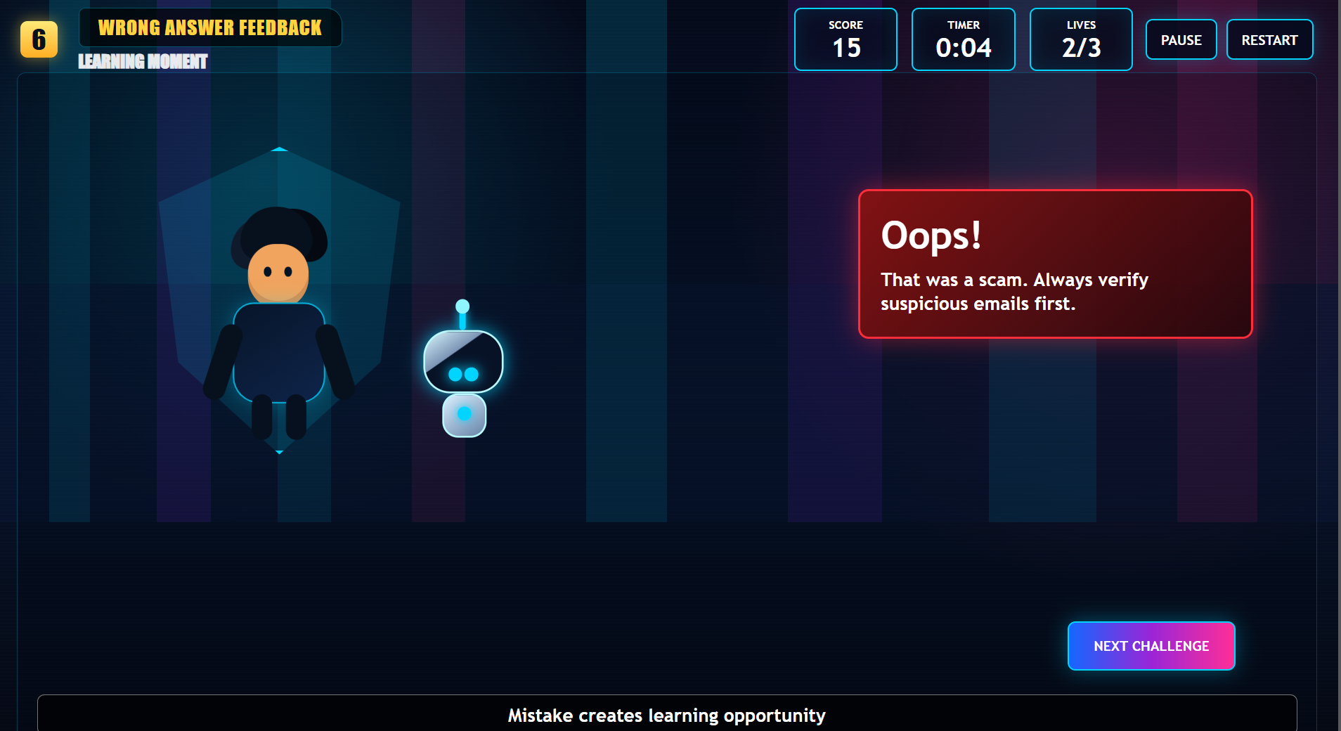  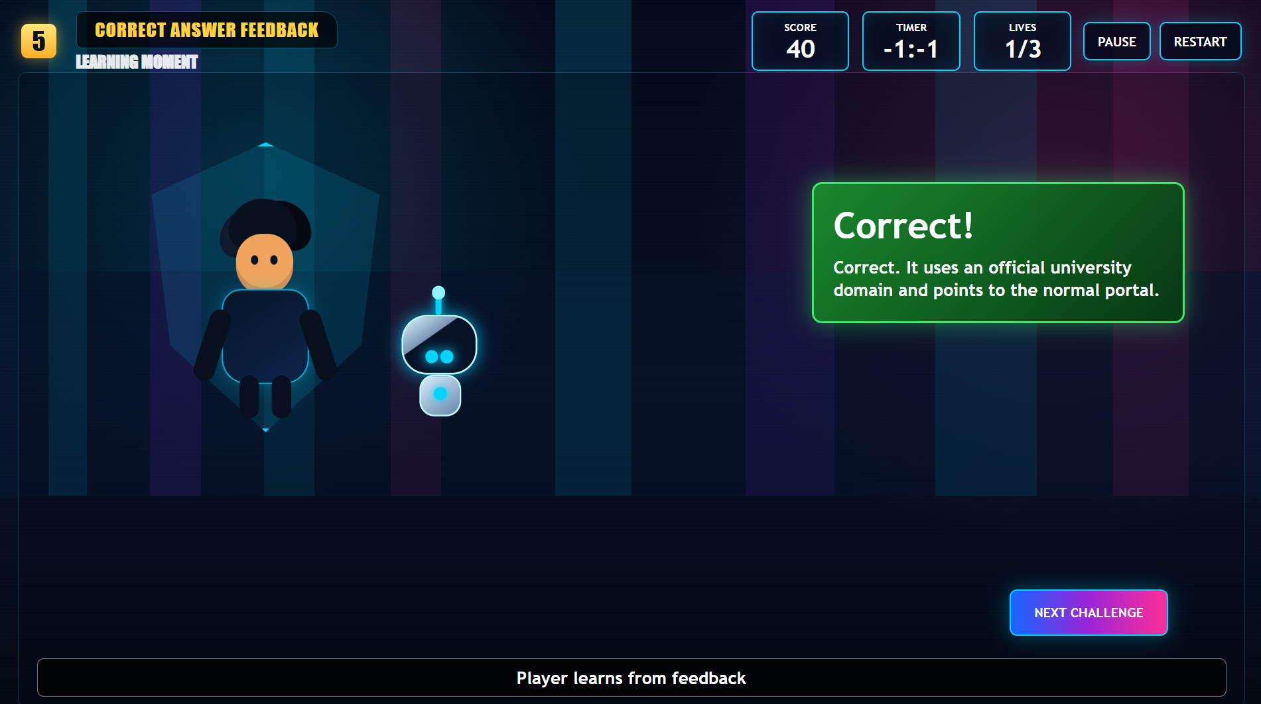
Reward/score | Add or improve point/star/badge/progress message | Vivek | 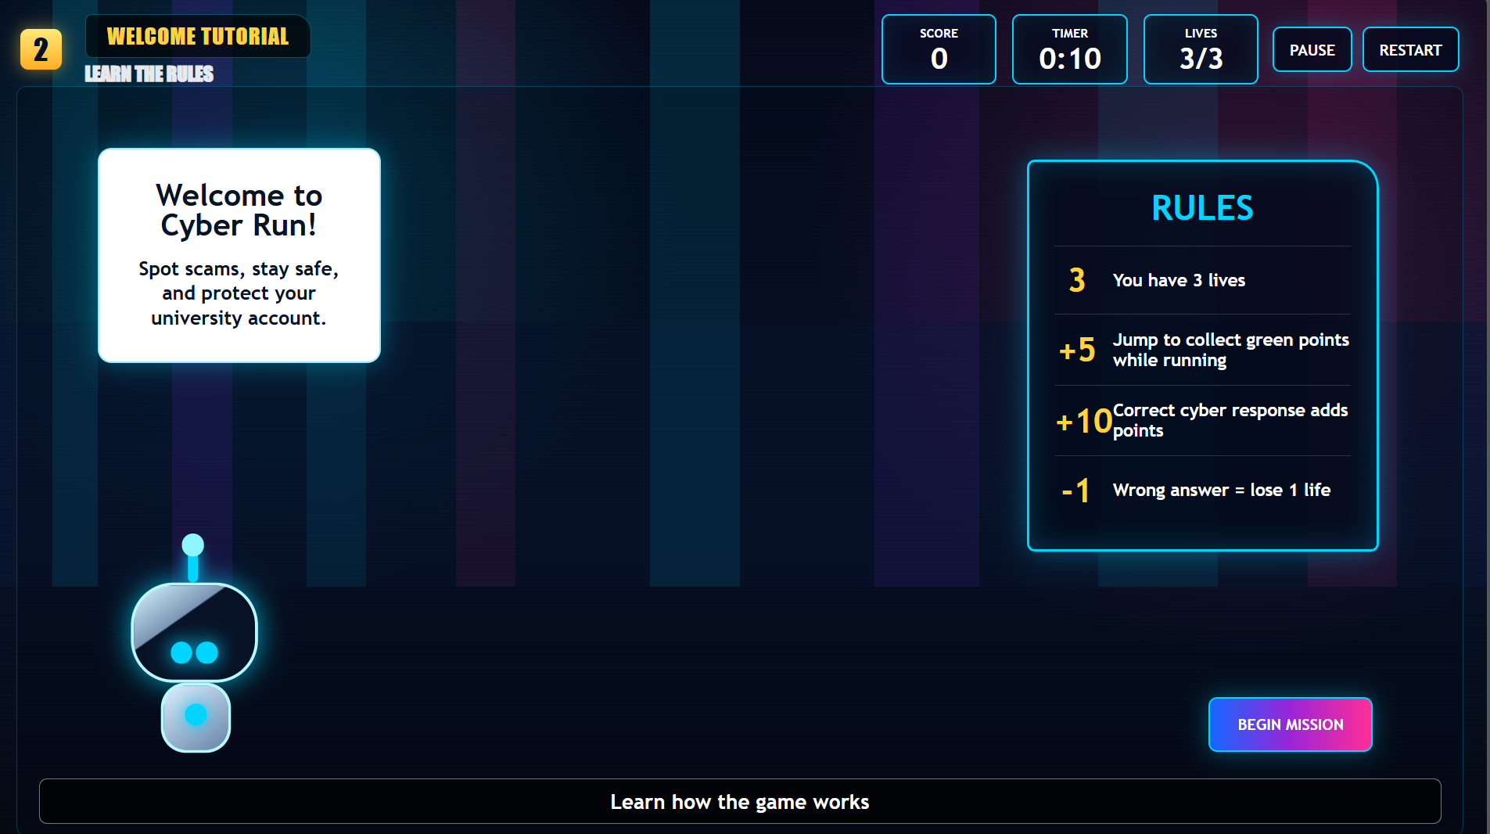  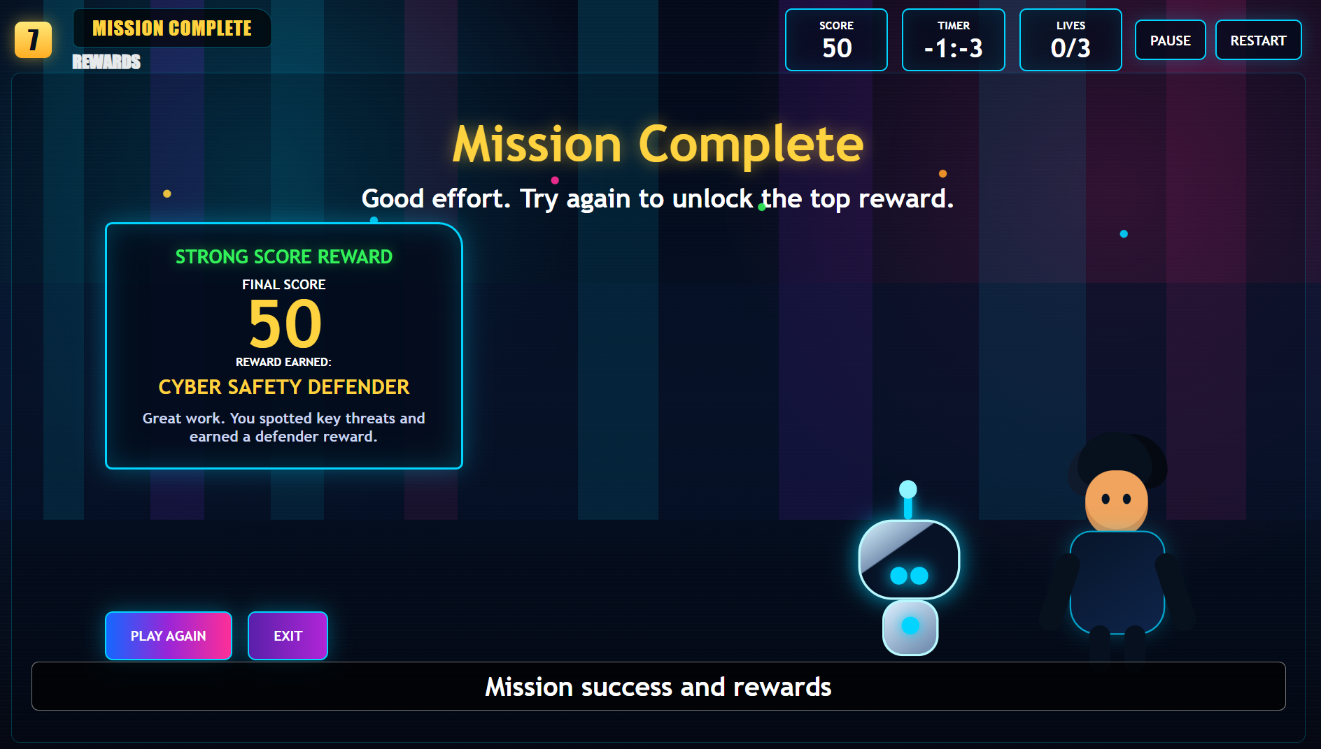
Accessibility | Readable text, clear buttons, suitable colour contrast, age-appropriate language | Vivek | 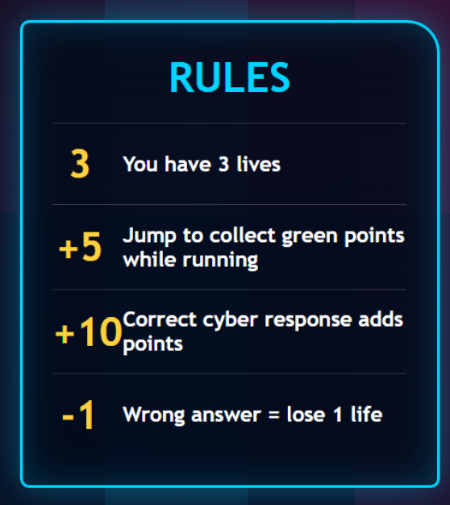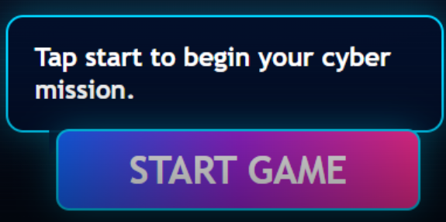  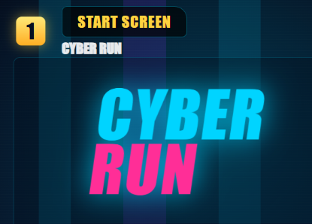

7. Task 3 - Test the Prototype and Record Evidence
What testing means this week
Testing does not mean the final game is complete. Testing means checking the current prototype to see whether it opens, works, is understandable, teaches the learning point, and is suitable for the target audience. Test what you have built so far.

Testing Instructions by Tool
Tool route | How to test | Evidence to upload
HTML / JS / CSS | Open the HTML file in a browser or with Live Server. Test every button/interaction. Check correct and wrong answers. Confirm feedback appears. | 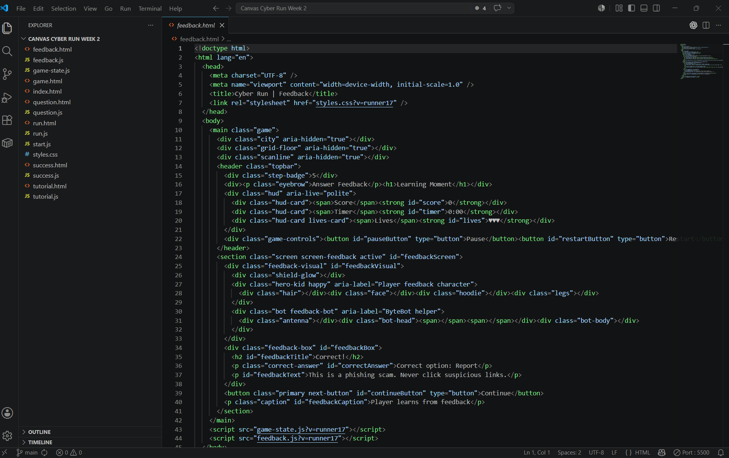

Testing Checklist
Testing question | Yes/No | Evidence or notes
Does the prototype open/start correctly? | YES | 
Is the welcome/title screen clear? | YES | 
Are the instructions easy to understand? | YES | 
Can the player identify what to click/do? | YES | 
Does the first cyber-safety challenge work? | YES | 
Does any new challenge/interaction work? | YES
Does the correct answer show useful feedback? | YES | 
Does the wrong answer show helpful feedback? | YES | 
Does the feedback teach a cyber-safety lesson? | YES | 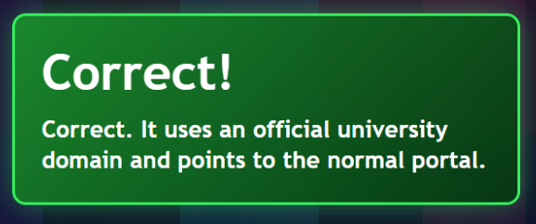  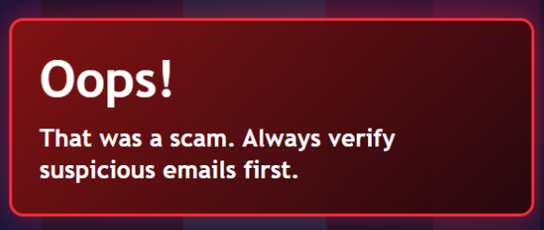
Is there a reward, score, star, badge or progress message? | YES | 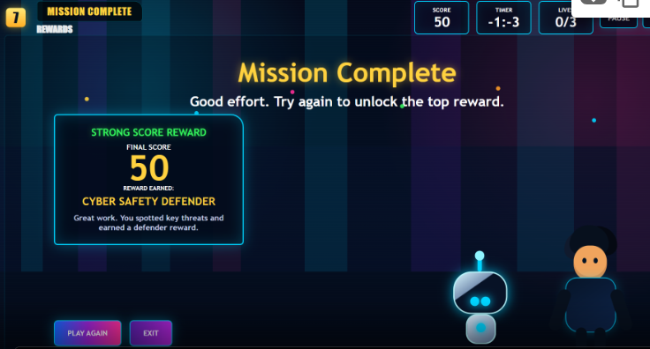
Is the prototype suitable for the target audience? | YES | Specially for 18-25 University students, who are receiving lots of phishing links related to university.
What must be improved before next week? | YES | New challenges with extra clarify feedbacks

8. Task 4 - Peer Prototype Review

Peer review item | Peer group response
Group reviewing
Group being reviewed
Tool used by prototype group | Scratch / HTML / Canva / PowerPoint / Other
One strength of the prototype
One issue/problem noticed
One improvement suggestion
Was the cyber-safety lesson clear? | Yes / No - explain
Was the prototype suitable for the target audience? | Yes / No - explain
Action the group will take after feedback

9. Task 5 - Create an Appendix Evidence Map

Appendix number | Evidence item | Date/week | Where stored in GitHub | Who is responsible
Appendix 1.1 | Team meeting minutes - Week 1 | WEEK 1  07/05/2026  08/05/2026 | 503IT-CYBERSECURITY-GAME-EDUCATION / WEEK 1 / Meeting Minutes-WEEK 1.docx | Hadshen
Appendix 1.2 | Team meeting minutes - Week 2 | WEEK 2  14/05/2026  15/05/2026 | 503IT-CYBERSECURITY-GAME-EDUCATION / WEEK2 / Meeting Minutes WEEK 2.docx | Hangma
Appendix 1.3 | Team meeting minutes - Week 3 | WEEK 3  21/05/2026 | 503IT-CYBERSECURITY-GAME-EDUCATION / WEEK 3 / Meeting Minutes WEEK 3.docx | Hadshen
Appendix 2.1 | Game Concept Canvas | WEEK 2  14/05/2026 | 503IT-CYBERSECURITY-GAME-EDUCATION / WEEK2 / SESSION 1 / CANVAS CONCEPT.pptx | Hangma
Appendix 2.2 | Storyboard | WEEK 2  14/05/2026 | 503IT-CYBERSECURITY-GAME-EDUCATION / WEEK2 / SESSION 1 / STORY BOARD.pdf | Vivek
Appendix 3.1 | Prototype Version 1 evidence | WEEK 2  15/05/2026 | 503IT-CYBERSECURITY-GAME-EDUCATION / WEEK2 / SESSION 1 / Prototype Version1 & Version2.docx | Swastika
Appendix 3.2 | Prototype Version 2 evidence | WEEK 2  15/05/2026 | 503IT-CYBERSECURITY-GAME-EDUCATION / WEEK2 / SESSION 1 / Prototype Version1 & Version2.docx | Swastika
Appendix 4.1 | Peer feedback and testing results | WEEK 2  15/05/2026 | 503IT-CYBERSECURITY-GAME-EDUCATION / WEEK2 / SESSION 1 / Testing-Plan.docx | Arbaaz
Appendix 5.1 | Individual contribution log | WEEK 2  15/05/2026 | 503IT-CYBERSECURITY-GAME-EDUCATION / WEEK2 / SESSION 1 / individual log | All members

10. Task 6 - Start the 15-Minute Group Presentation Plan

Slide/section | Content required | Speaker | Time
1. Title | Project title, module, group members | Hangma | 30 sec
2. Problem | Cyber-safety issue being addressed | Hadshen | 1 min
3. Target audience | Who the game is for and why | Swastika | 1 min
4. Game concept | Game idea, learning objective, core gameplay loop | Hangma | 2 min
5. UX/accessibility | How the design supports the user | Hadshen | 1.5 min
6. Prototype demo | Show the working prototype or visual demo | Vivek | 3 min
7. Testing and feedback | What testing showed and what was improved | Arbaaz | 2 min
8. Team collaboration | Roles, meetings, task management, GitHub evidence | Vivek | 2 min
9. Individual contributions | Each member briefly explains contribution | All member | 1.5 min
10. Conclusion | Summary, next steps, professional learning | Arbaaz/ swastika | 30 sec

11. Task 7 - Start Individual Portfolio / Report Planning
Important
The individual portfolio is not a group report. Each student must write their own report and explain their own contribution, reflection, evidence and professional development. Start planning now.

Portfolio section | What to write | Evidence to link
Introduction | Briefly introduce the project, game topic, group role and aim. | Project title and group overview
Project planning and teamwork | Explain meetings, role allocation and how the team organised work. | Meeting minutes, role allocation, action logs
Personal contribution | Explain exactly what you personally did. | GitHub commits, contribution log, files/screenshots
Prototype development | Explain how the game/prototype developed over time. | Canvas, storyboard, prototype screenshots, testing notes
Communication and collaboration reflection | Reflect on teamwork, communication, conflict, feedback and improvement. | Peer feedback, meeting minutes, reflection log
Professional development | Explain what you learned for future professional practice. | Reflection entries and action plan
AI use statement | Declare how AI was or was not used. | AI use log
Appendices | Include supporting evidence in labelled appendix sections. | Appendix evidence map
GitHub files to create
Week-3-Portfolio-Planning/individual-report-structure.md
Week-3-Portfolio-Planning/portfolio-evidence-linking-plan.md

13. Three-Week Remaining Work Plan
Week | Main focus | What must be completed
Week 3 | Prototype development, testing, appendices and presentation planning | Prototype Version 2, testing results, appendix evidence map, presentation draft plan, report structure
Week 4 | Full prototype improvement and first presentation run | Improved prototype, updated testing, first full slide deck, first full presentation practice, individual report draft
Week 5 | Final polish and submission preparation | Final prototype/demo evidence, final presentation, final individual portfolio, appendix check, references, AI statement, submission readiness

14. End-of-Week 3 Checklist
Checklist item | Yes/No | Evidence/file location
Independent team meeting completed | YES | Uploaded in GitHub, 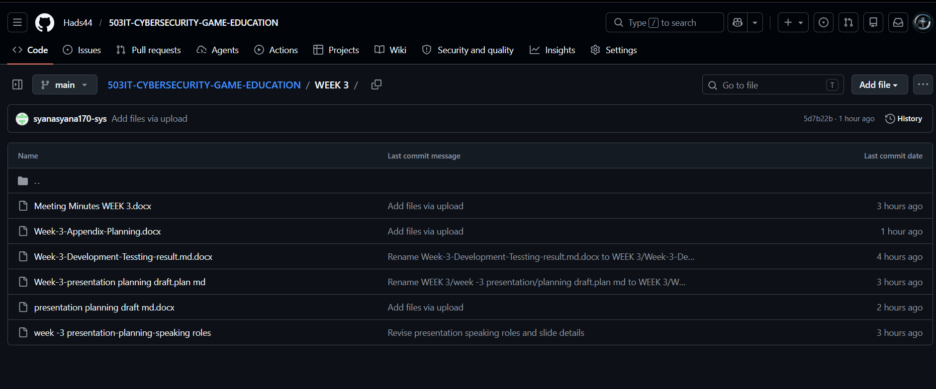
Meeting minutes uploaded | YES
Prototype Version 2 plan completed | YES
Prototype Version 2 evidence uploaded | YES
Testing results completed | YES
Peer prototype review completed | YES
Appendix evidence map created | YES
Presentation draft plan created | YES
Individual report structure started | YES
AI use log updated | YES
Individual contribution logs updated | YES
Every group member has at least one visible Week 3 commit | YES

15. Group Member Completion Table
Student name | Student ID | GitHub username | Main Week 3 task completed | Commit message / evidence uploaded | Signature
VIVEK | 15845159 | Vivek-424 | Development Plan & game prototype | Uploaded in GitHub  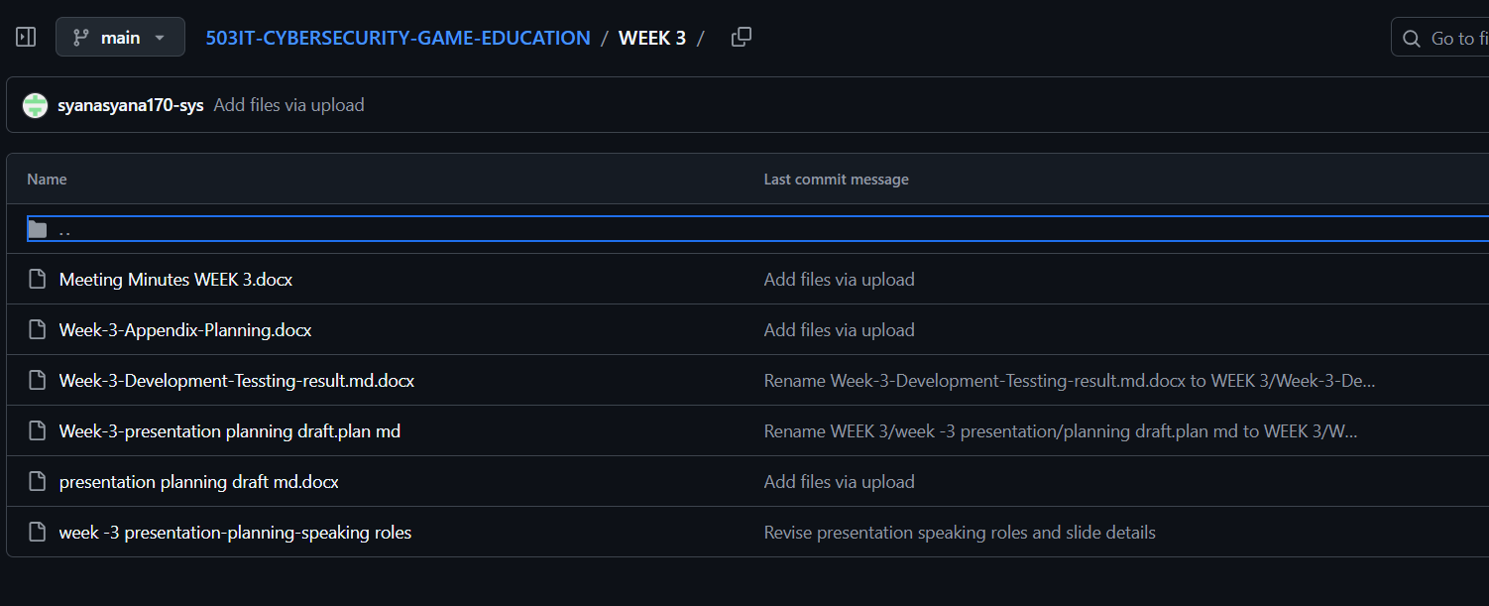
HADSHEN | 16247806 | Hads44 | Report writing
HANGMA | 15209959 | Hangma16 | Presentation planning
SWASTIKA | 15728966 | syanasyana170-sys | Appendix Planning
ARBAAZ | 16200513 | arbaazulhaqqqsfj-web | Portfolio & Presentation slides

